Data Analytics Intern Assignment – Summary Report
Name: Komal Jain
Role Applied: Data Analyst Intern
Company: Virex Media
Tools Used: Python, Pandas, Matplotlib
Objective of the Assignment:
The objective of this task was to perform basic data analysis on a delivery dataset using Python.
The focus was on data understanding, simple analysis, visualization, and drawing meaningful insights.
Key Findings
- Mobile products had the highest number of orders.
- Earphones showed the best delivery performance with lower average delivery time.
- Bangalore recorded the highest average delivery time among all cities.
- Most deliveries were completed successfully, with a smaller percentage being delayed.

Figure 1: Orders per Product Type Figure 2: Average Delivery Time by City

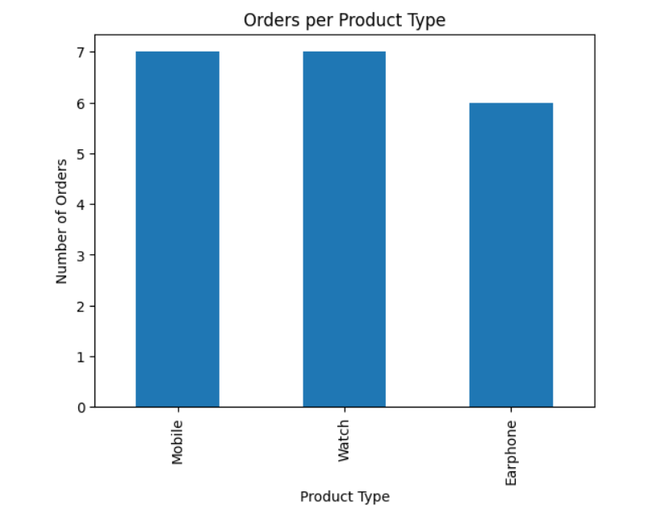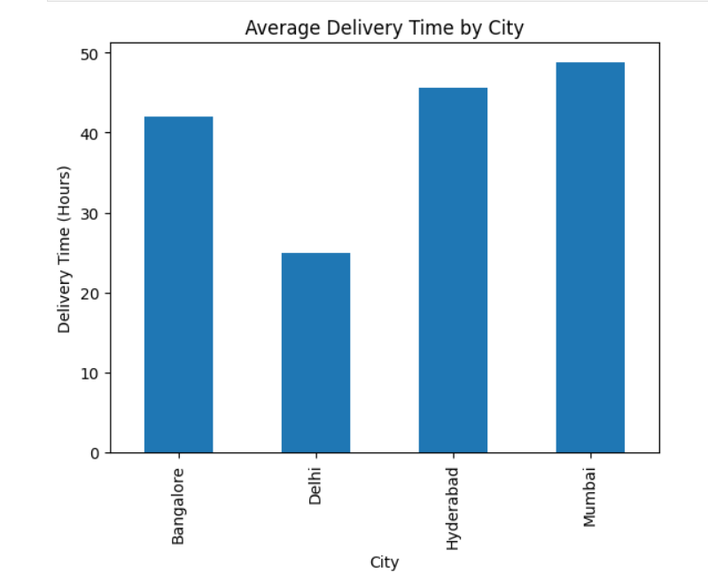
Figure 3: Delivery Status Distribution
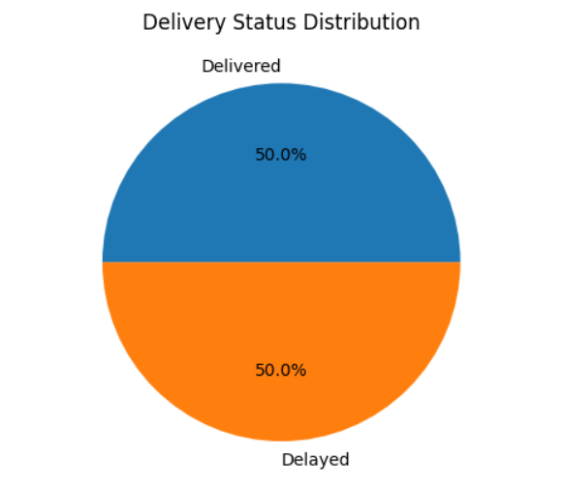
Insights & Recommendation
- Insight:
Earphones have the most efficient delivery performance, while Bangalore faces more delivery delays.
- Recommendation:
Delivery efficiency can be improved by optimizing logistics and increasing fulfillment capacity in high-delay cities such as Bangalore.
Conclusion
This analysis helped identify delivery performance trends across products and cities.
Basic data analytics techniques were effectively used to derive meaningful insights from the dataset.

